Student Booklet
Health and Social Care: Level 3

Introduction to Health and Social Care: Level 3
To be completed and taken with you on the first week of 6th Form
Websites to be used to complete the activities:
https://www.nhs.uk
https://www.healthcareers.nhs.uk/explore-roles
https://www.tutor2u.net/hsc/reference/stress-diathesis-model
https://www.tutor2u.net/hsc/topics/activity-theory-havighurst
https://www.tutor2u.net/hsc/topics/social-disengagement-theory
https://www.bbc.co.uk/bitesize/topics/zwds7p3

Welcome to health and social care

I have tried to give you a number of tasks on the following pages to help you to move from year 11 to Sixth Form.
The tasks relate to common themes that you will study throughout your course.
If you have any problems, please contact Mrs Edwards or Mrs Burns via email
M.Edwards@hughfaringdon.org
L.Burns@hughfaringdon.org
– We can help you as far as possible.

- Multiple Choice Questions
Answer the questions that explore the main themes of the unit
- Growth and development mean different things in Health and Social Care. Which definition best describes growth and development?
- Development is physiological and refers to weight and dimensions
- Growth is an increase in a measured quantity and development is the acquisition of skills and abilities through the life stages
- Growth refers to physical concepts and development refers to intellectual developments

- Complete these sentences.
- A definition of gross motor skills is:
_____________________________________________________________________
_____________________________________________________________________

- A definition of fine motor skills is:
_____________________________________________________________________
_____________________________________________________________________

- Identify if these are gross or fine motor skills. Write G (gross) of F (fine) in the box.
A | Gross or fine motor skill?
B | Jumping
C | Picking up a pen
D | Threading a needle
E | Doing up a button
F | Climbing stairs

- Write the name of the theorist by each theory title
- Acquisition of Language
- Theory of Cognitive development
- Theory of attachment
- Sequences of Attachments

- Which is Nature? Which is Nurture?
- Genetic predisposition
- Modelling behaviour
- Bandura
- Gesell

- Complete these sentences with words / phrases from the box
Respiratory disorders / overcrowding / long and short term health problems /allergies / damp / poor ventilation / asthma /

- Poor housing conditions can lead to __________________________________________

- Three features of poor housing are:
1 ____________________________
2 ____________________________
3 ____________________________

- Three health problems could be
1 ____________________________
2 ____________________________
3 ____________________________

- Here are factors that may affect development. State if they are physical / social / economic / environmental.

Family dysfunction
Exposure to pollution
Employment status
Genetic predispositions
Education
Culture, religion and beliefs
Low income family

- Complete the sentences.

The Holmes Rahe social readjustment scale looks at predictable and unpredictable life’s events

Starting school and retirement are ___________________________________________

Divorce and sudden death of a partner are ____________________________________

- Draw a time line with THREE predictable life’s events from birth through to early adulthood.
Draw a timeline with THREE unpredictable life’s events from middle adulthood through to later adulthood.

- Effects of and changes in ageing in later adulthood – identify if these effects of ageing are:
Physical /intellectual / emotional / social – you will need to use some words more than once:

A | Dementia
B | Retirement
C | Osteoarthritis
D | Degeneration of taste buds
E | Loss of independence
F | Loneliness
G | Cardiovascular issues

- Identify two health and social care services that could help people to live independently in later adulthood.

- These two theories commonly refer to which life stage?

- Social disengagement theory: __________________________________

- Activity theory: _____________________________________________

- Identify which of these SIX issues limit social interaction.

Poor public transport
Membership of a social club
Playing team sports
Death of a partner
Financial worries
Family and friends living far away
Living in a big house with space to entertain
Poor health
Belonging to a church group and community
Increased leisure time
Ill health of relatives and friends

- Which way around? Complete the sentences picking the TWO correct phrases from the table below:
- Income is ____________________________________________________

- Expenditure is ________________________________________________

how much people spend / not having enough money to pay bills / the amount of money households receive / experiencing poverty

- Pick the correct FIVE groups of people more likely to be on low income:

Families in secure employment
Sick people with disabilities
Families with inherited wealth
Older people
Healthy people
Families where one or both parents are unemployed
Families with only one parent earning
Lone parent family with parent working as a doctor in a hospital
Lone parent families

- Pick one correct definition for the word STRESS and one correct definition for the word DIATHESIS.

A predisposition to physical ill health
More inclined to become anxious
Ability to cope with pressure
A predisposition towards a mental disorder
Pressure / tension / strain

- These key words refer to theorists. Name the theorist and the theory – you may need to use some theorists more than once.

Word | Theorist | Name of theory
- Sensorimotor
- Acquire language
- Positive reinforcement
- Pre-operational
- Negative reinforcement
- Attention
- Maturation
- Genetic predisposition
- Schemas
- Unpredictable life event

- A Theory

Write these words out in order 1-4:
Motivation / Attention / Reproduction / Retention
Name the theory and the theorist.
- A Theory

Write these words out in order 1-4:
Formal operational / Sensorimotor / Concrete operational / Pre operational
Name the theory and the theorist

- Anatomy and Physiology

Project Human Skeleton

For this part of the human skeleton activity, you will need to print off the parts of the skeleton, single sided (some printers default to double sided). If you have no access to a printer, how about drawing/copying the bones.

There are a variation of options for this part of the activity, depending on your access to resources/materials……

If you have card, even better, print straight onto card or print on paper and then stick onto card, like a cereal box or one of those big Amazon boxes they use for a small order!
Cut out the different sections of the skeleton and either stick them onto paper or the back of a roll of unused wallpaper. You could make some parts moveable with split pins, if you have them or use small holes and wool.
For the next activity then you could leave a ‘tab’ on the side of the skull to glue it down but allow it to be flipped over. If you do this with the skull and also the rib cage, you will able to add the brain, underneath the skull and the heart, lungs, stomach etc under the rib cage and the perhaps add the reproductive organs in the pelvis cavity.
Now….. name your skeleton and name/label each bone

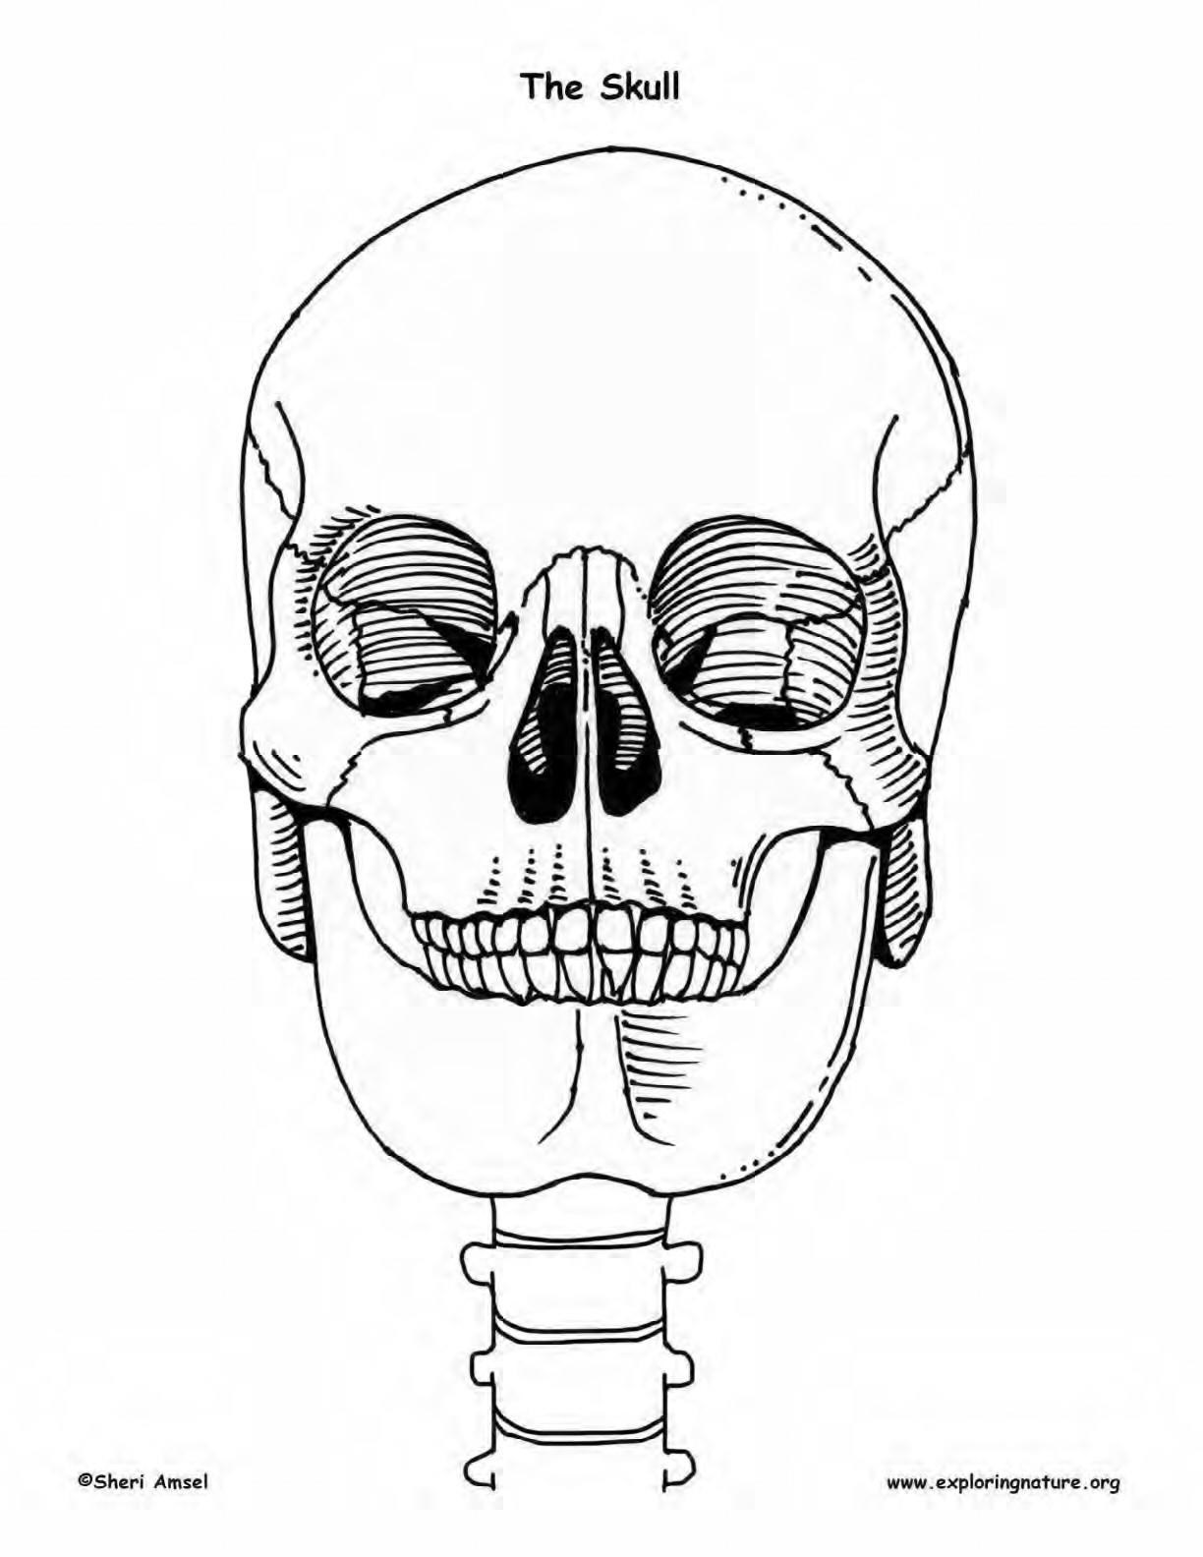
Year’s
9
/
10
/11

>

Independent or group

activity

Don’t forget to
create a ‘tab’ to
stick down and
allow the skull to
flip back

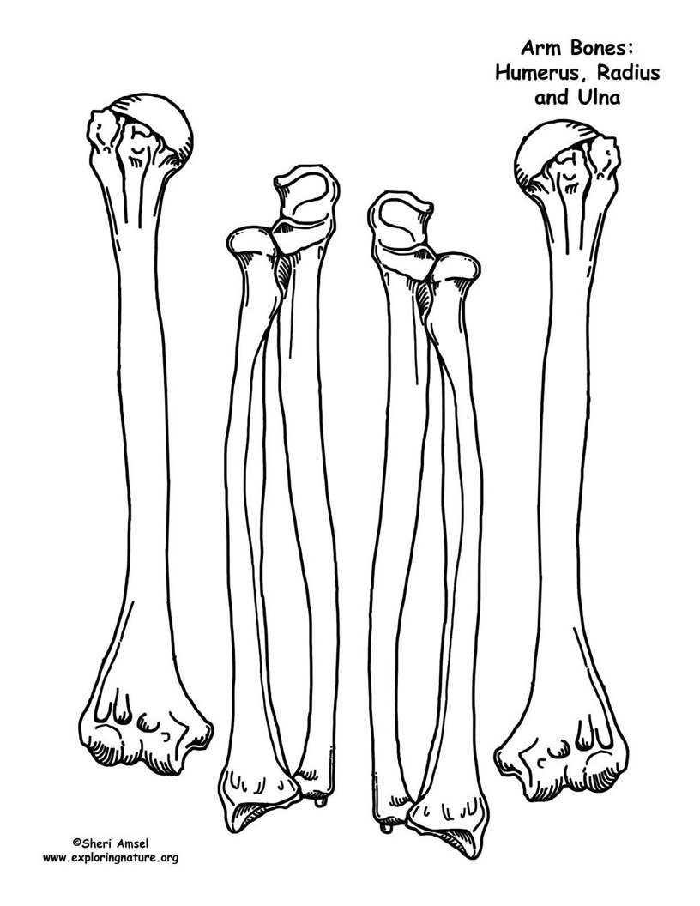
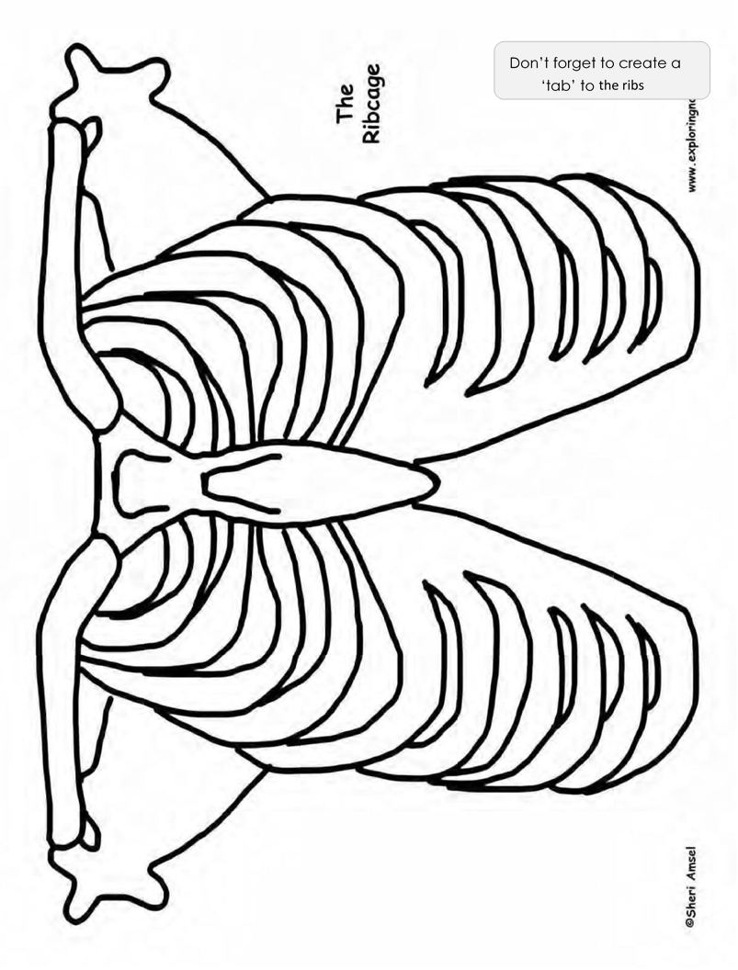

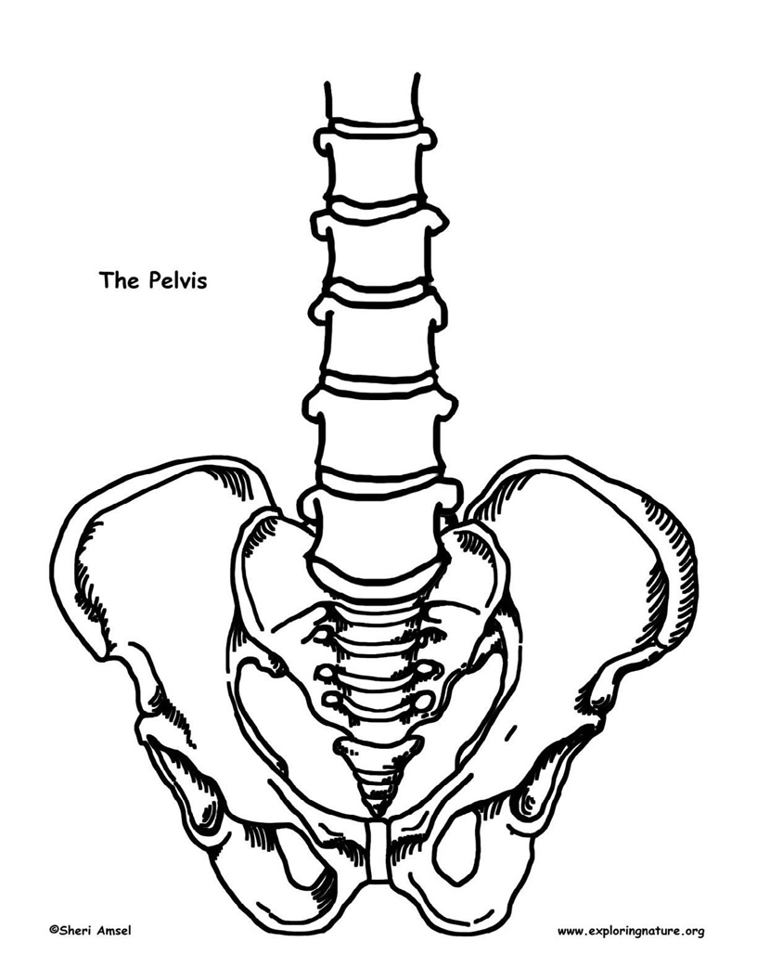

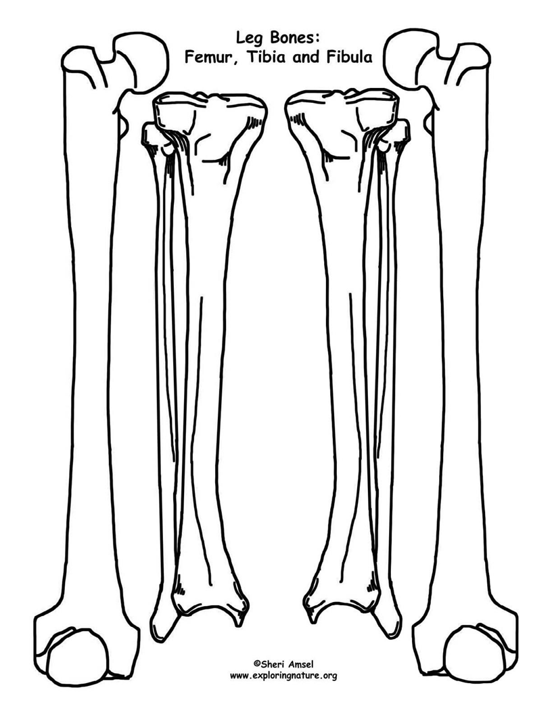

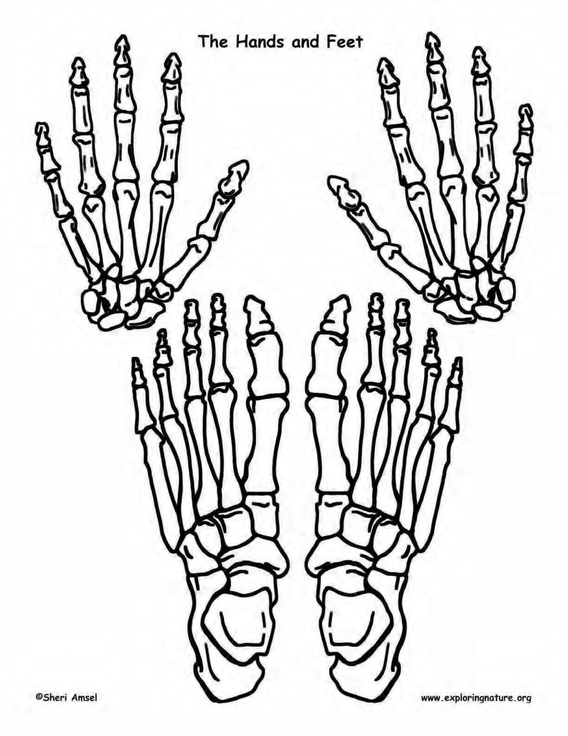
Year’s
9
/
10
/11

>

Independent or group

activity

Short Answer Quiz
The skeleton forms the frame for the body and makes up about one fifth of the body’s
weight. It is made up of ___________ bones. It also includes cartilage, joints, and ligaments. Besides for forming our body frame, the skeleton has several other jobs. It is the anchor and support for all our _________________________________ and even our organs. It protects our vital organs like the brain, spinal cord, heart and lungs. It allows us to move with muscles attached by ______________________________________, using the bones as levers. It is a place for our body to store minerals, like ______________________________________. It is where the body makes most of its new _________________________________ cells. Bones come in many shapes and sizes. The long bones have a long shaft and two bigger ends.
These include the bones of the arms and legs. The largest bone in the body, the
___________________________, is a long bone. It is 2 feet long and hollow, to make it lighter. It is very strong to support the body’s weight. The short bones are cube-shaped and include the bones of the wrist – the carpals, and the bones of the ankle – the
____________________________.
The flat bones are thin, curved and flattened like the ____________________________

and skull. Lastly, there are irregular bones such as the vertebra and pelvis. Each section of

the skeleton has a job. They work together to make the body a strong, moving machine.

Watch

The following links will send you to some documentaries within health and social care. Some of them are a hard watch. If you can’t watch them please don’t worry.
- https://www.bbc.co.uk/iplayer/episode/m0005jpf/panorama-crisis-in-care-part-1-who-cares
A Panorama programme that follows four families. This is a tough one.

- https://www.channel4.com/programmes/old-peoples-home-for-4-year-olds

A channel 4 experiment that looked at what happens when 4 year olds befriend the elderly. A lovely series although you will need a channel 4 on demand login.
- https://www.channel4.com/programmes/24-hours-in-ae
Follows the work of the emergency department at a busy London hospital. Some of you may find some of the images worrying as they are real and some of you don’t enjoy the sight of the human body!
- https://www.netflix.com/search?q=d&suggestionId=6839_genre&jbv=80174177&jbp=4&jbr=0
Those of you on Netflix “What the Health”, an American documentary about the Pharmacutical industry as well as health. A little controversial in some places.

